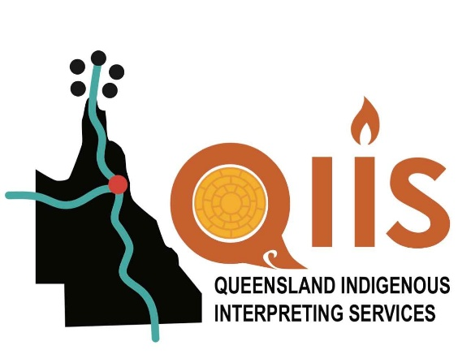

Queensland Indigenous Interpreter Booking Form

Please fill out as much of the booking form as you can. Then e-mail it to QIIS@aiwaac.org.au
We assess your request to ensure appropriate cultural, ethical and linguistic placement, check availability of interpreters and contact you for confirmation of your booking.
You will receive a tax invoice by e-mail
______________________________________________________________
Information about your client / client group

Name:

Community:

Age:

Gender:

Language: 2nd language:

______________________________________________________________

* In case of a cancellation within 24 hours, a cancellation fee will be charged.
For assignments up to 1 day, the full rate will be charged. For longer assignments,
one third of the total amount will be charged.

** It is the obligation of the person booking the interpreter to inform this service immediately should any irregularities in the interpreter’s performance occur.

** Please also note our minimum charge out rate is for a minimum of three hours.

Booking Form Page 2
______________________________________________________________

Information about your organisation

Your Name:

Position:

Name of organisation or Department:

Phone: Mobile:

Booking Person’s Email:

Email address for invoices:

Address:

City/Town: State: Postcode:
____________________________________________________________

Information about the interpreting interview

Person to contact for briefing:

Topic:

Date:

Time:

Location:

Nature of Engagement: (please provide as much information as possible to ensure the interpreter is appropriate for your assignment and prepared)

Special instructions:

For Office Use Only:
T/A
Flights/Coach/Ferry
Taxi
Fuel
Accommodation

