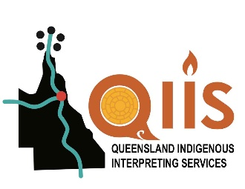
Booking Form
Translations

Please fill out as much of the booking form as you can. Then e-mail it to QIIS@aiwaac.org.au
You will receive a tax invoice by e-mail
_______________________________________________________________________
Information about your Translation

Specify if script is to be

- Recorded

- Written

- Filmed

__________________________________________________________________

Specify length of recording

- 30 seconds

- 60 seconds

- Other - Please specify

___________________________________________________________________
___________________________________________________________________
Target communities: (eg – whole of state, region or specific communities)

______________________________________________________________________________________________________________________________________

Languages required:

______________________________________________________________________________________________________________________________________
* In case of a cancellation within 24 hours, a cancellation fee will be charged.
** Please also note our minimum charge rate of three hours.

Booking Form Page 2
______________________________________________________________

Information about your department

Your Name:

Position:

Name of department:

Phone: Mobile:

Booking Person’s Email:

Email address for invoices:

Address:

City: State: Postcode:
____________________________________________________________

Information about Translation

Person to contact for briefing: __________________________________

Topic (Please attach script): ___________________________________

____________________________________________________________

____________________________________________________________

Special instructions: ____________________________________________________________

____________________________________________________________

____________________________________________________________

